**MS Dial guidelines**

**Sharepoint server:** \\mdcislressmb01.adsroot.uts.edu.au\proteomics\Projects\C3\Matthews

**Importing the data**

1. Open MS Dial v 5 or higher (this is for version 5.1.230719)
2. To open recent projects, select Load project, or from the list on the right. Look for a .mdproject file. This will open all the alignment files for that project.
3. For a New Project
   * requires you to set a path of the project. **Must match the data files (.raw file)**
4. Next – browse
   * Open .raw files (you might need to change the file type in bottom right box to view your .raw files – circled in red) (all files including blank and PBQC)
   * Select all data files to import – click open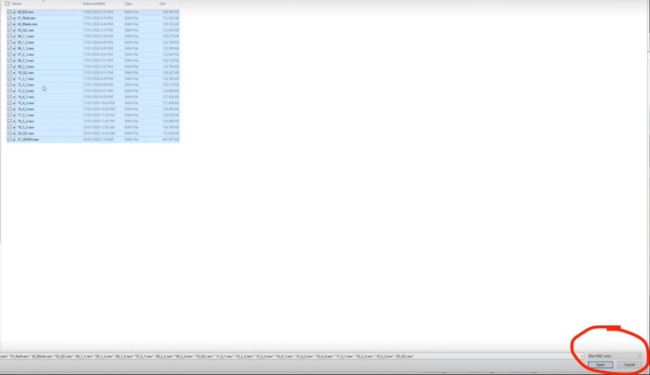
5. Fill out class ID column – segments samples into treatments. You can copy and paste from and excel sheet. Go to the top samples and **use ctrl+v not right click**.

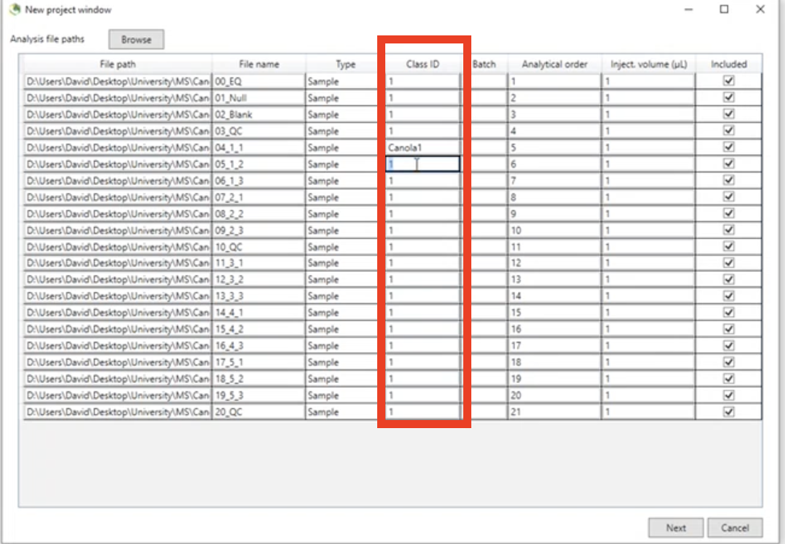

1. Click next
2. Use these settings
3. Data type - If using QE+/orbitrap data (what we typically use), **Data type for MS1 and MS 2 = Profile data**. Hover mouse over profile or centroid data to see which machines have which data
4. Target omics - If doing lipidomics and want to use the internal library (suggested for untargeted work) select lipidomics. If you want to use a specific/external library, select metabolomics.
   1. Note that if using an external library, the software has bias toward the internal library and will give better scores for internal library matches.
   2. **To produce own spectral library:** New software: Lipid Spectrum Generator
5. Ion mode – you will need to repeat the data processing if both +ve and -ve modes were used. Select one at a time.

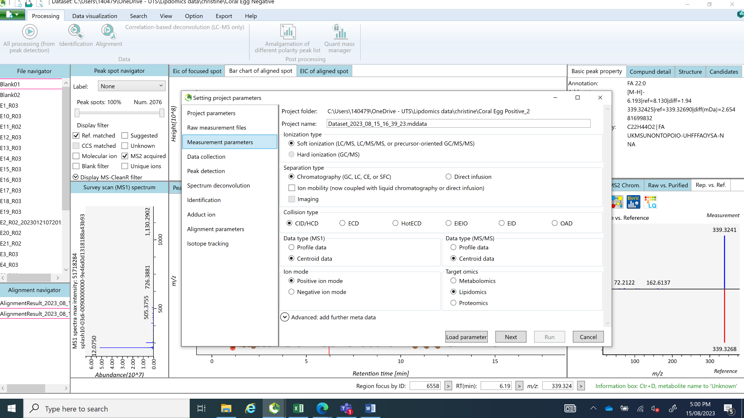

1. Next
   * Enter settings as below
2. Data collection tab
   * Note – multithreading – change the number of threads to however many processors your computer has. You will find this out under setting (e.g. device manager) in your PC
   * Execute retention time corrections – **leave unticked during first processing**

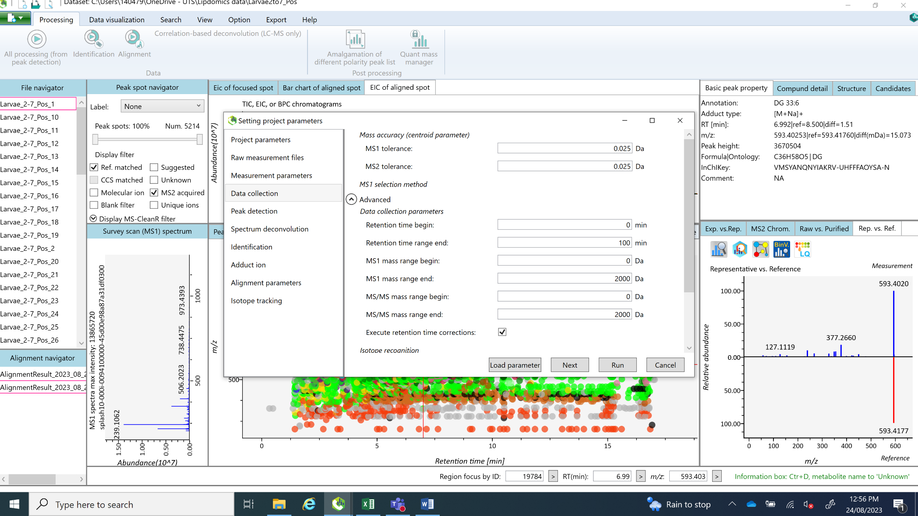

1. Peak detection tab – as default (for orbitrap, can change min. peak height to 10,000 (up to 50,000))
2. Deconvolution parameters – as default
3. Identification
   * If using lipidomics, don’t change MSP file (library)
   * Accurate mass tolerance
     + MS1 0.05
     + MS2 0.075

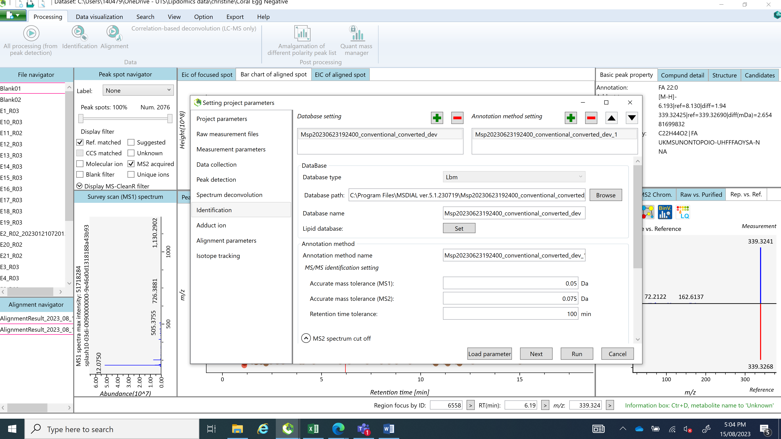

1. Adduct
   * IF IN NEGATIVE MODE - Select [M-H]-, [M-H2H]2-, [M+CH3COO]-
   * IF IN POSITIVE MODE – SELECT [M+H]+, [M+2H]2+, [M+H-H2O]+ (in case some source fragmentation occurs), [M+NH4]+, [M+Na]+
   * You can add your own using User defined adduct

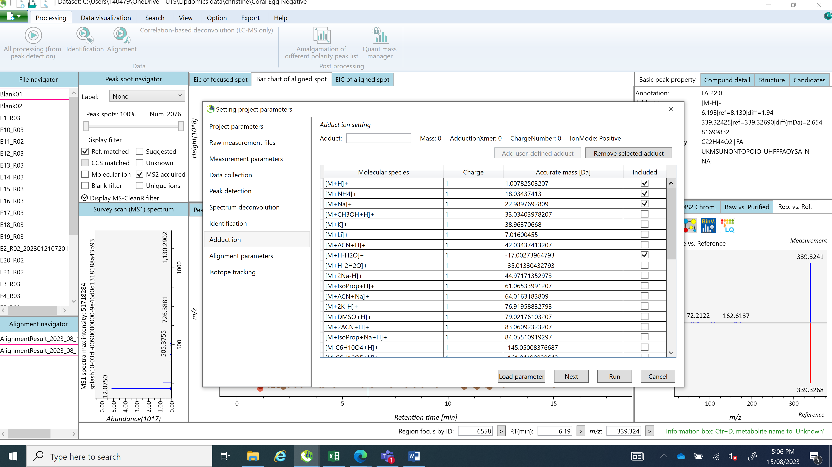

1. Alignment
   * This is where the library aligns to your data.
   * Select the PBQC sample with the biggest file size as the reference file (all your PBQCs should be included in the run, but here you can only select a single file, so chose the largest file size).
   * Change MS1 tolerance to 0.05
   * Remove features based on blank – I generally blank correct after the data export instead of using this.
     + if you do tick, it will remove all features from your sample files if in the blank, except above a certain threshold (dictated by the sample mass/blank average below – 5 fold change is suggested).

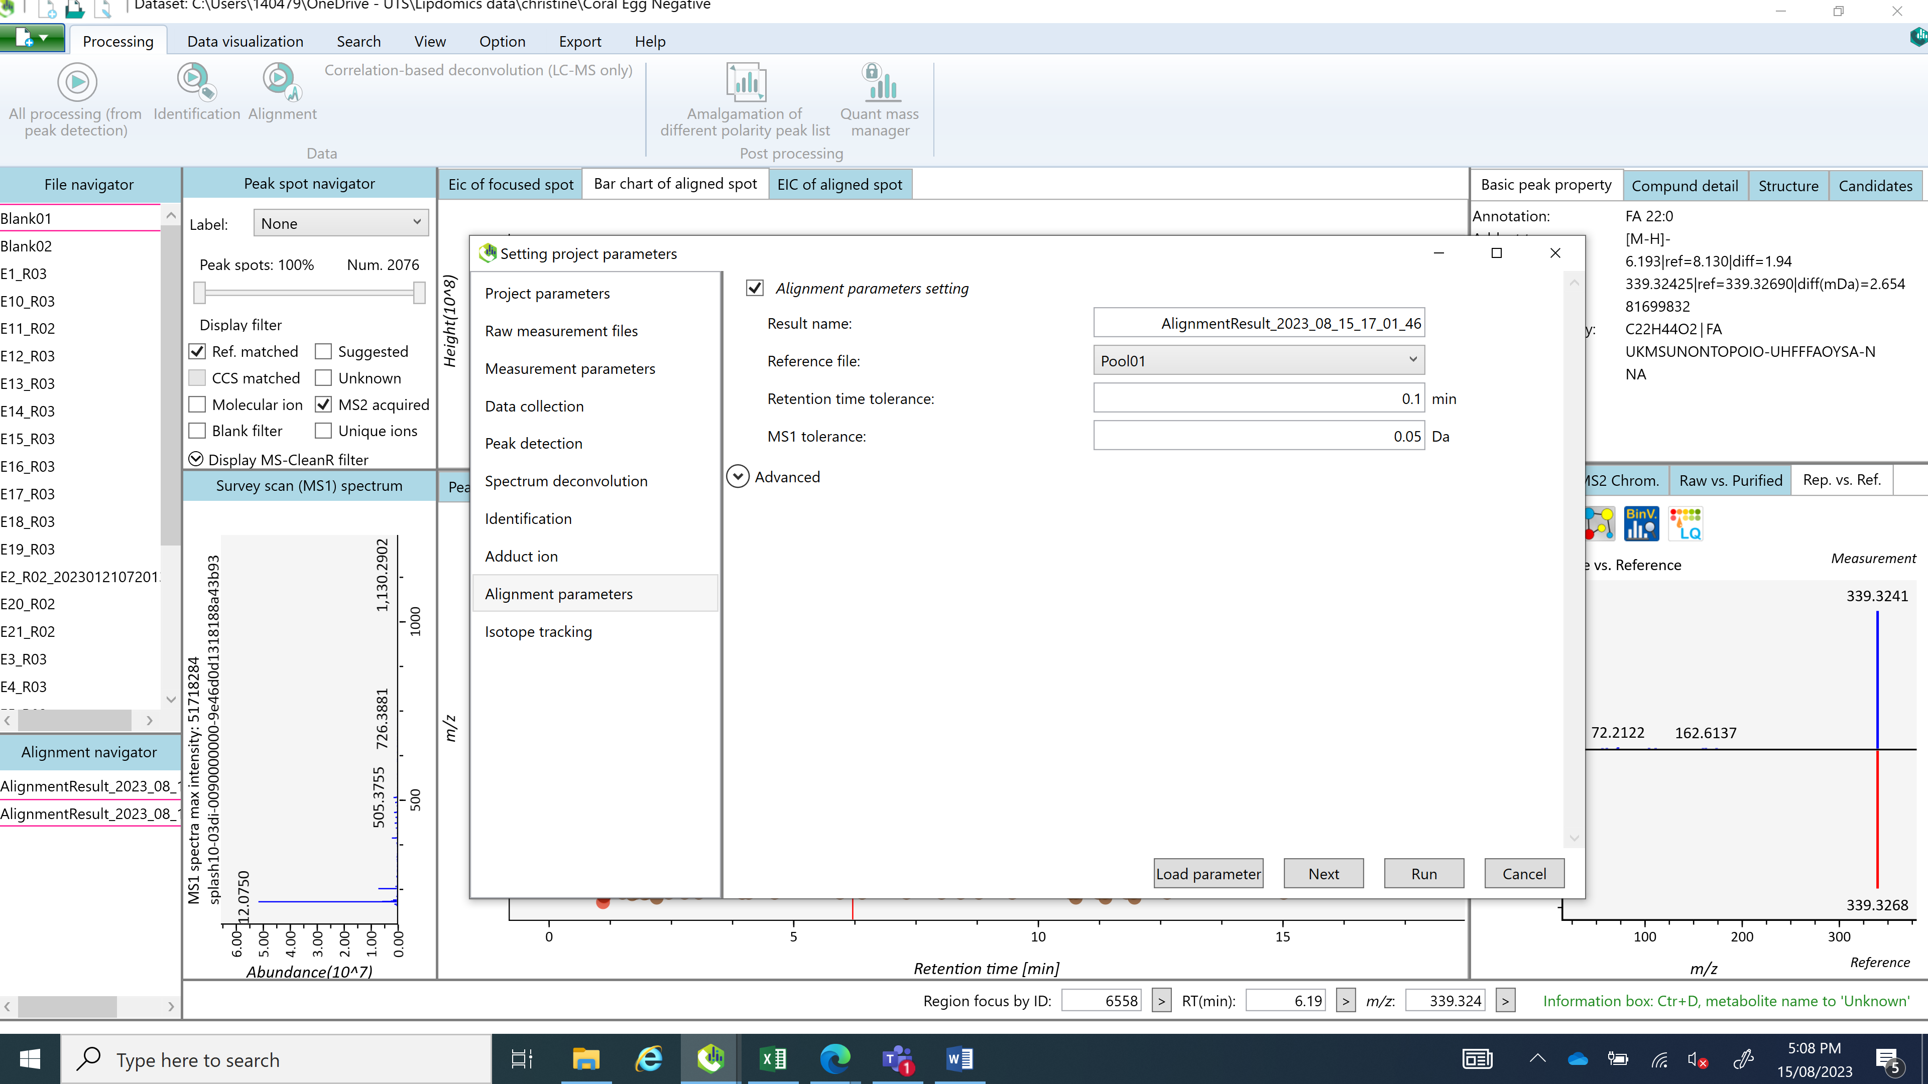

1. Click Run – this can take some time, depending on how many samples you have
2. Click to view the alignment results (bottom left - 1)
3. Select Ref. matched (2) under Peak spot navigator to see whats been matched to library. Bar charts are treatment averages with error bars (3)
4. Click show ion table (4)

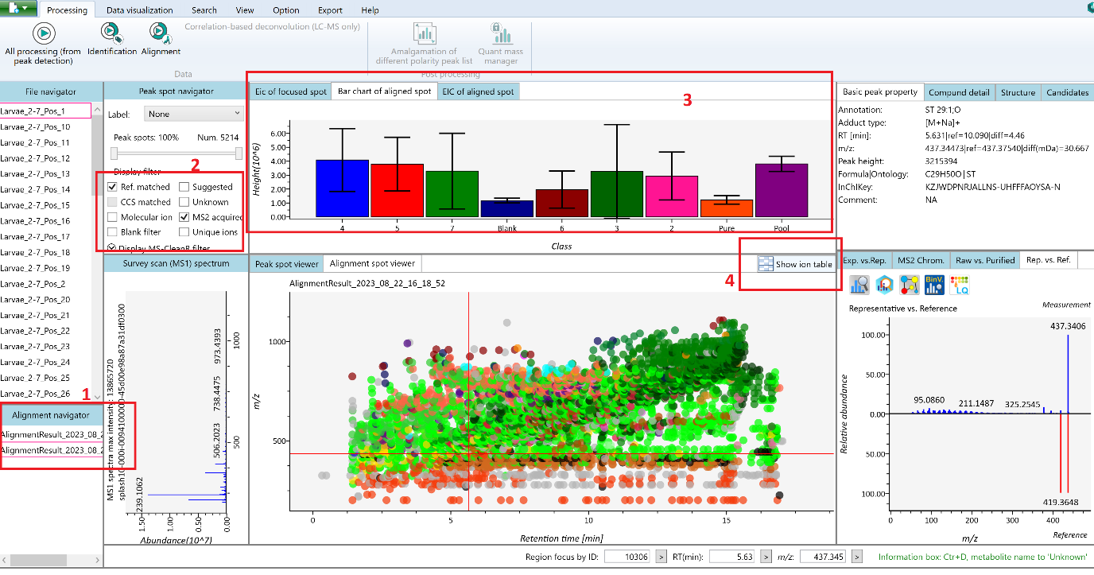

**SAVE PROJECT!**

**Retention time alignment**

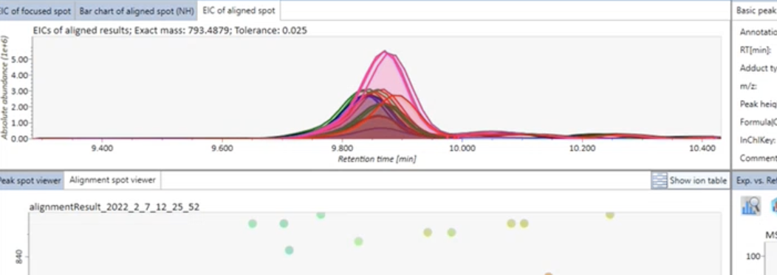

As seen here, the peaks are not perfectly aligned, so we need to correct that to make sure all peaks are identified the same.

1. Open ion table. Type d7 in metabolite name.
2. Notice the RT and M/Z. if you have multiple peaks, check which has the most consistent level across samples/bars (as this is your internal standard and you added it to your samples so it should be identical, theoretically)
3. Repeat searching for d9.

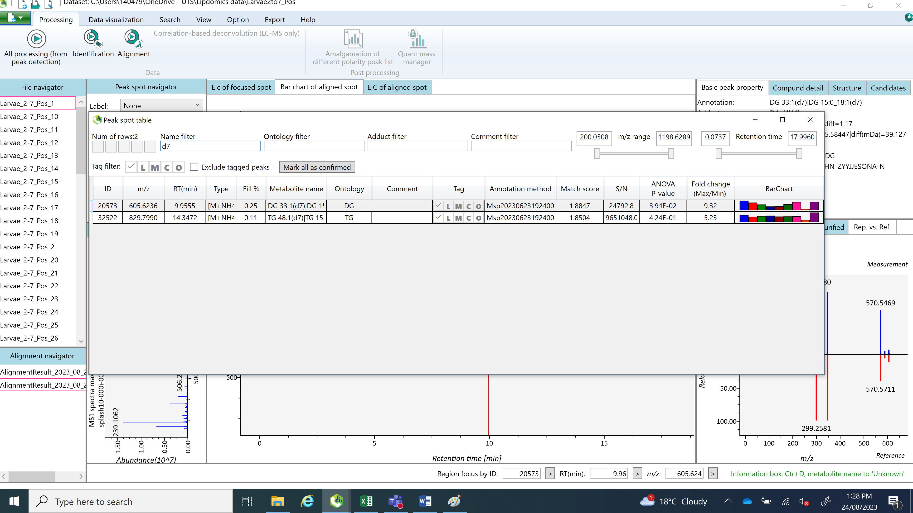

1. Note these in a text file (as below) and save as text file.

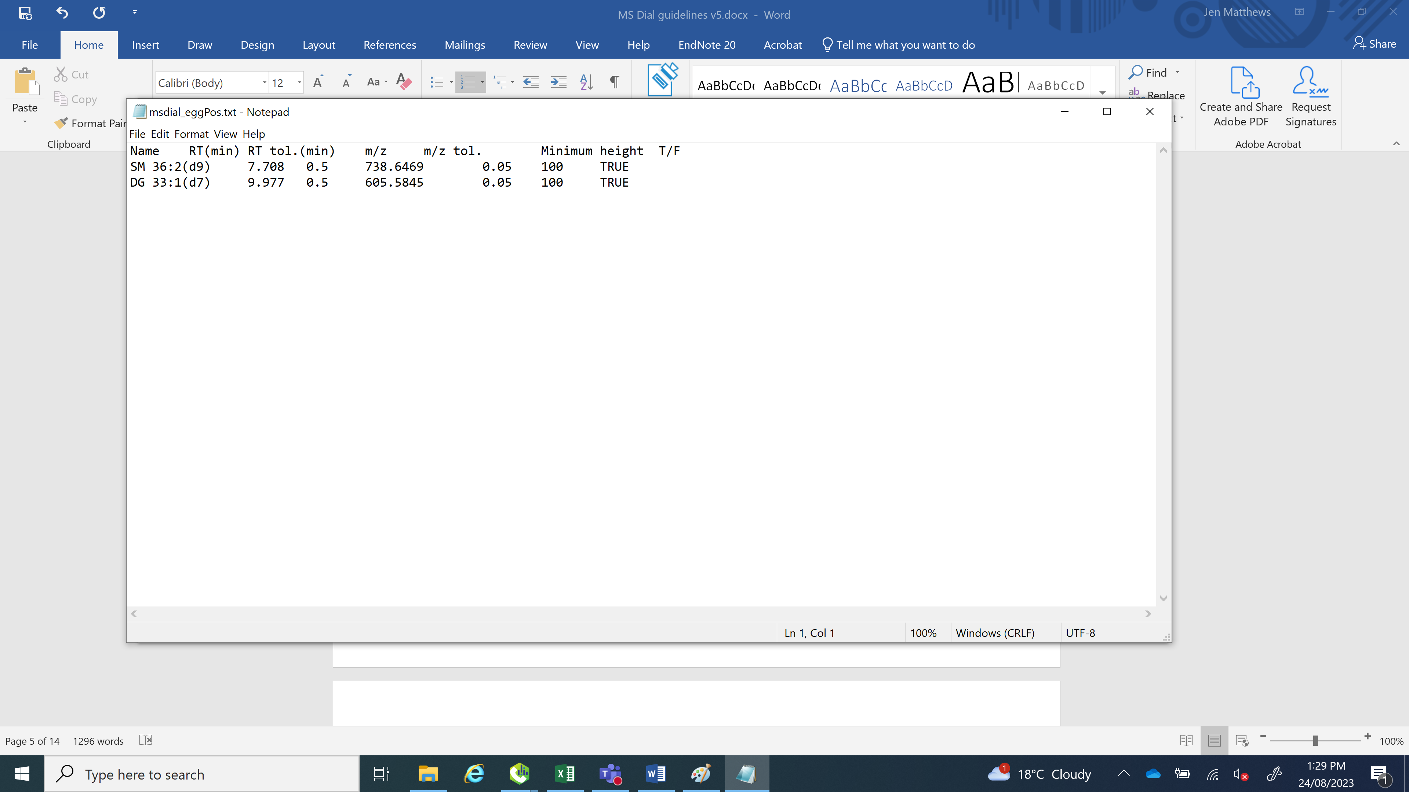

1. All processing (from peak detection) – under data collection tab, under advanced, tick execute retention time corrections

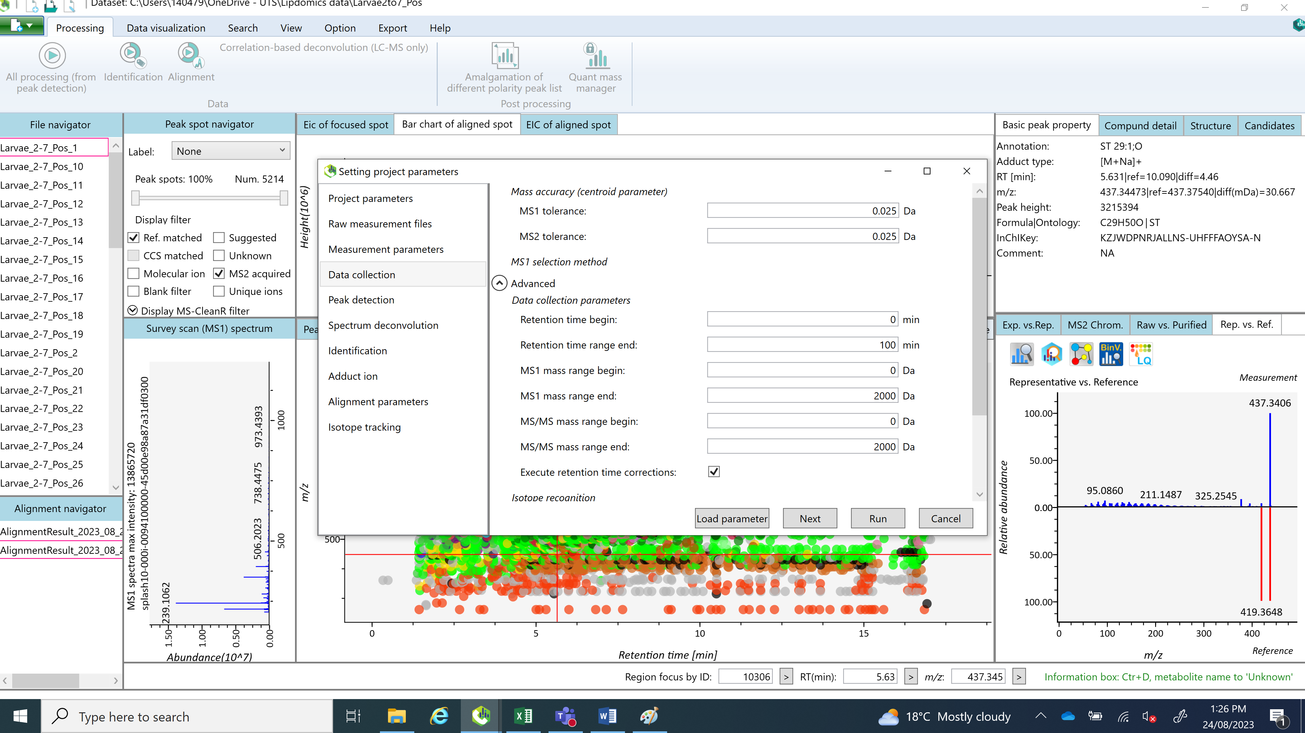

1. It will open the retention time correction box
2. Click Browse Ref File, and load the text file
3. Click RT correction - it will run an overview of the retention times.

If you’re happy with it (i.e. no widely different samples) click Run. THIS CAN TAKE A LONG TIME! Depends on how many processors you are running.

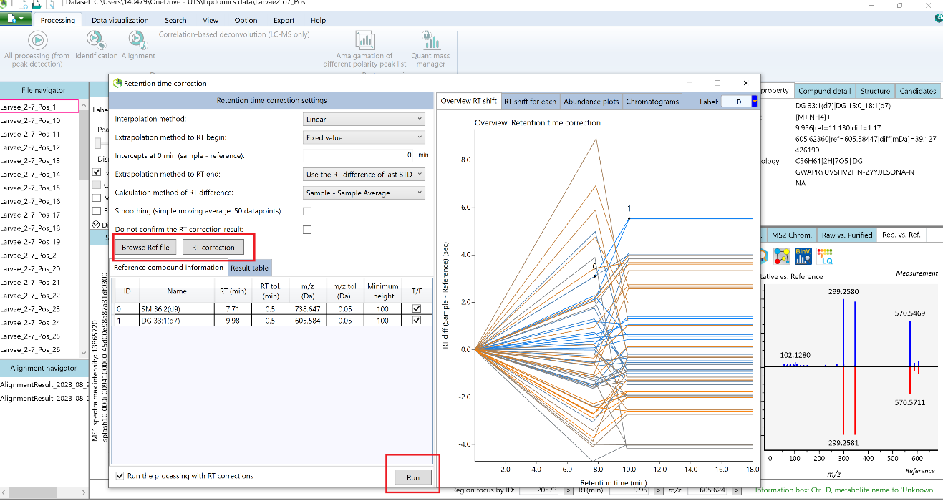

**This will provide a second alignment file.**

Now the peaks are better aligned:

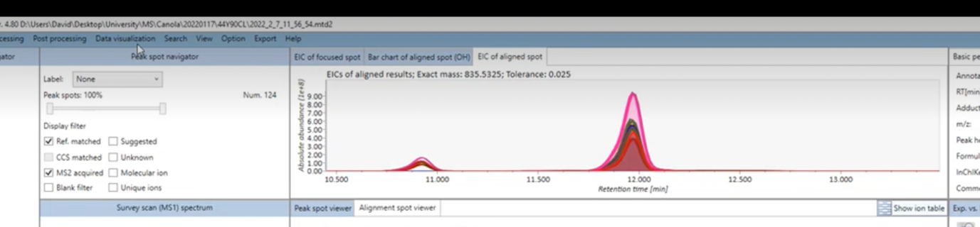

**SAVE PROJECT!**

**Cull repeated lipids**

1. Open your ion table
2. Order by metabolite name
3. Go through the peaks, and compare to decide which peak to keep for that compound
   * the quality of the peaks (nice smooth peak across samples)
   * the spectra matches – that blue bars generally match the mirrored reference data red bars
   * look for compounds with the highest peak abundance (ideally > n7)
   * use the match score
   * check it’s higher in your samples than the blanks
4. for bad peaks – in the Tag column, select the L – low quality spectrum
5. for the peak you want to use – select the tick in the Tag column.
6. You can keep more than one if you can’t decide! We just rename them lipid_1 and lipid_2. Use the tick for both, and use one other tag (any will do – C for coelution for example) so that you can filter them in excel later.

Bad peak:

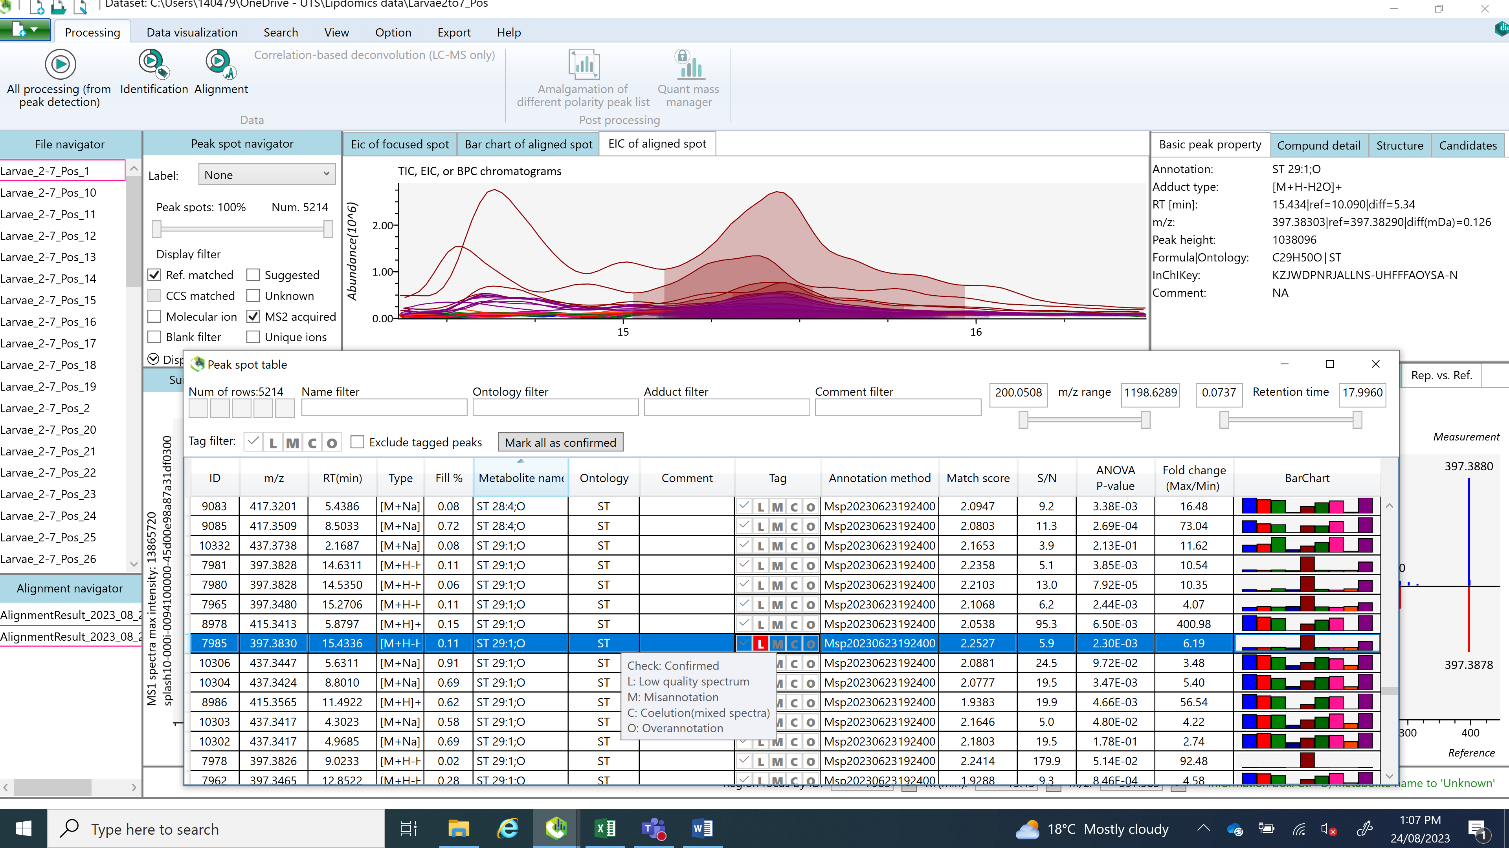

Good peak:

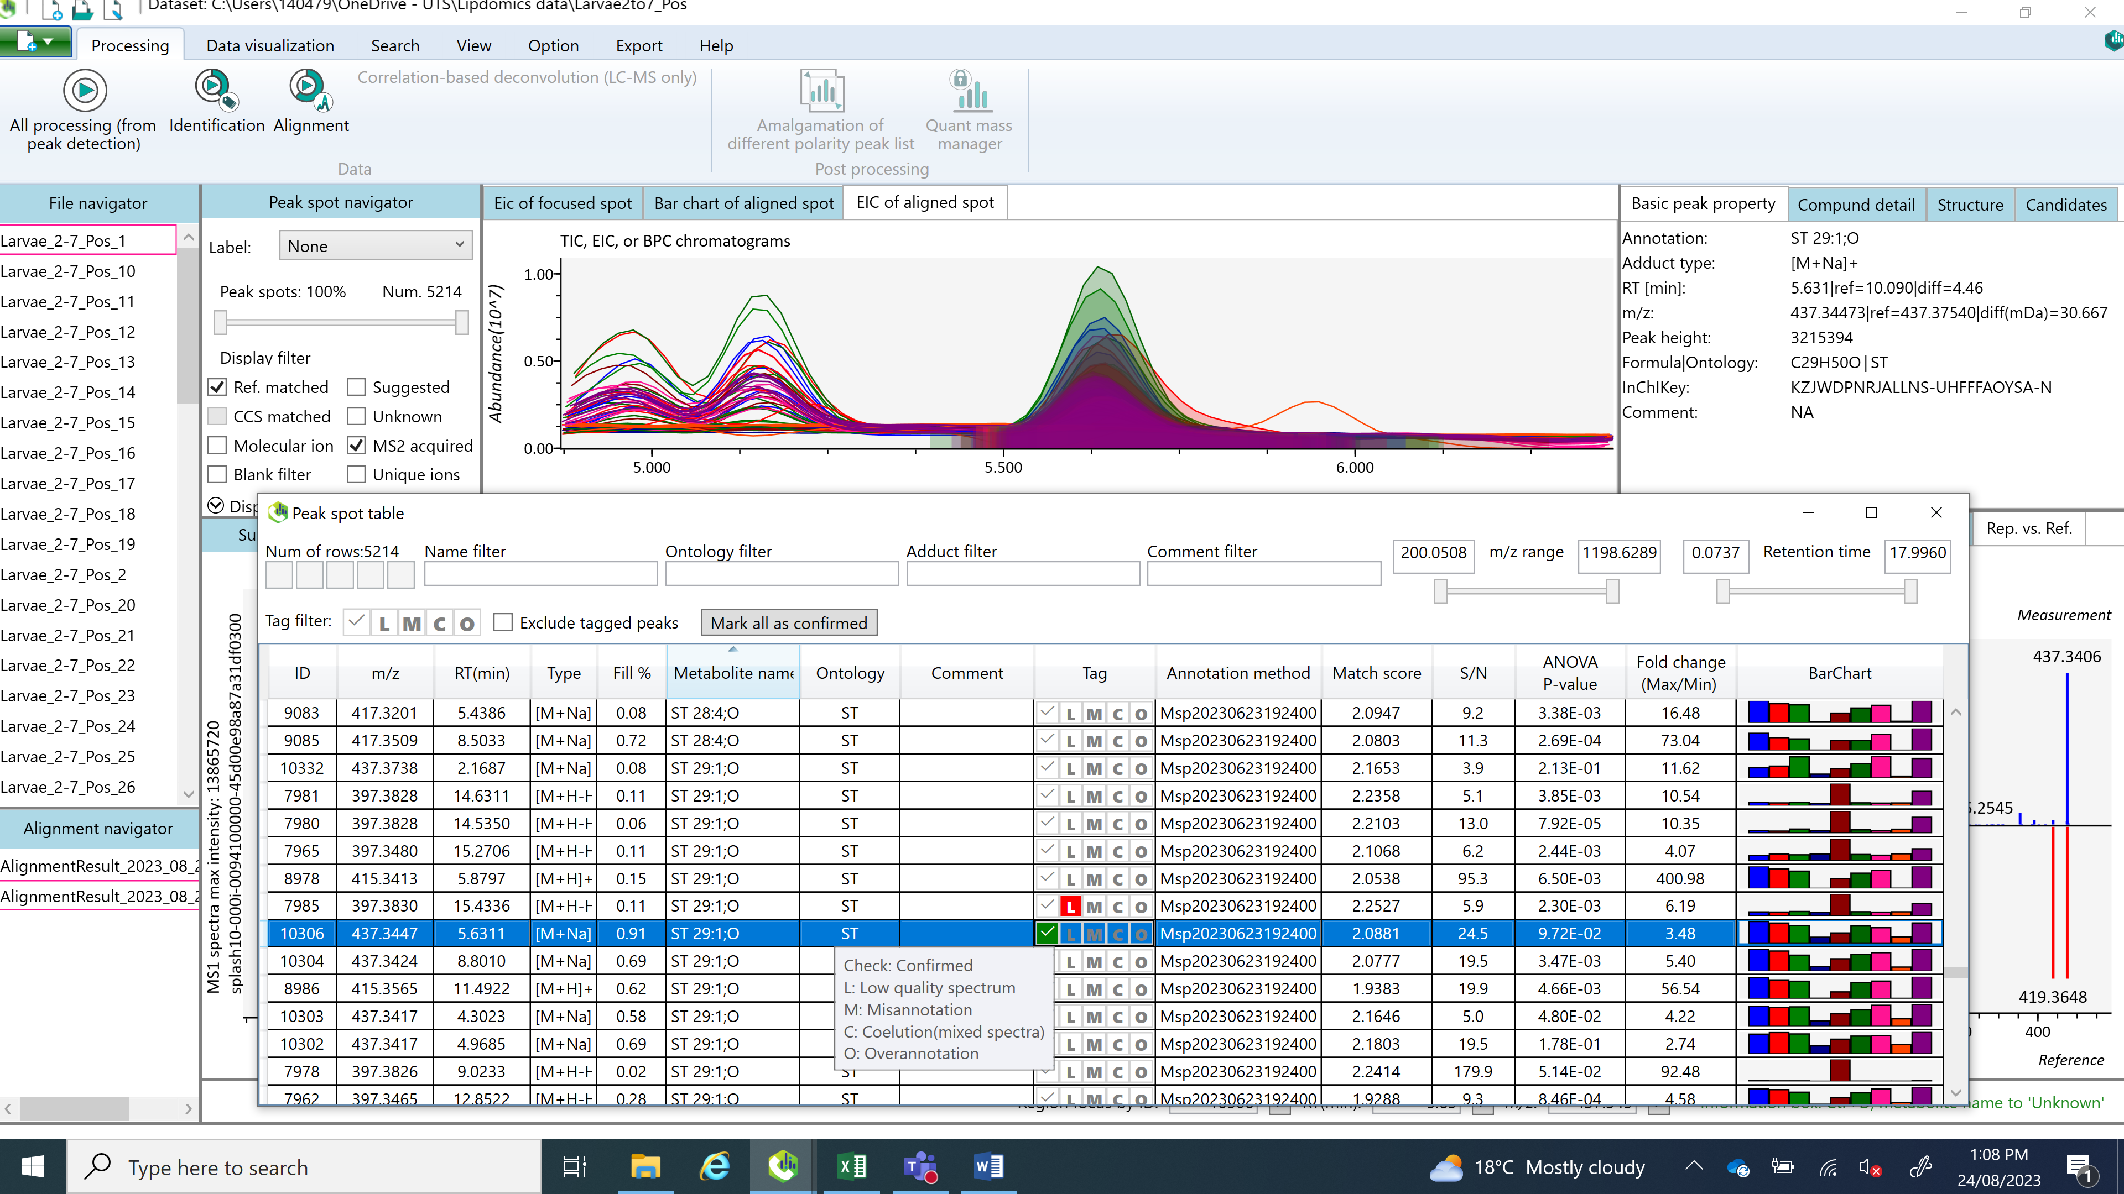

If there are any that you are missing and think should be there, click Suggested. Make sure you check the spectra peaks.

Selection criteria

1. Clear peak with samples aligned
2. Present in PBQC
3. Highest concentration if peak is good (>10^6, preferably 10^7 or more)
4. Didn’t keep any that showed up in one group without being present in PBQC
5. Kept multiple if all criteria met

370 in negative after selecting, 1198 before (31%)

1471 in positive after selecting, 2904 before (50%)

**Normalisation**

**NOTE: you can do this here, or after data export manually. I have found that manually can sometimes work better.**

1. Go to Data visualisations – Normalisations
2. In the list, select Splash lipidomix
3. Click find compounds
   1. These should match the internal standards you use for RT correction earlier
   2. Different ion modes (negative/positive) will return different standards. Not all standards will be detected.
4. Scroll to the bottom (sometimes off the screen annoyingly, so you might need to move the taskbar to the right hand side of your screen) and click Normalize

This will normalize every peak to your internal standards

Normalized as described. Seemed to work well in negative. Units now in nmol/uL plasma

For positive, clicked “find compounds” and deleted those with -1 not found

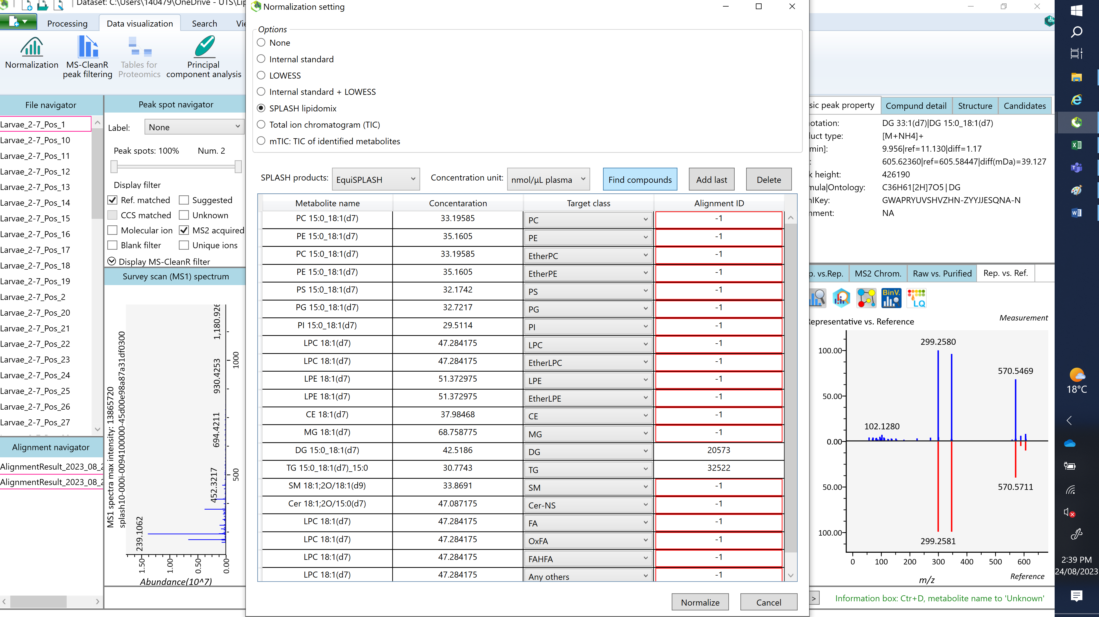

To do it manually, in your exported data in excel, divide all peak areas by one of the peak areas of your internal standard – Use the best looking/most consistent standard peak.

Need to do blank

Notes from prelim exploration:

* Mcap neg 1 was different than other samples, may need to remove. Often had weird peaks – could be because it was run first; was far from other samples when I ran a prelim PCA in the software

**Exporting the data**

When you are happy with the data, you can export to excel:

1. Export – alignment result
2. Select where you want to export to
3. Export both the Raw (Area) and Normalized data (Area)
4. Select csv

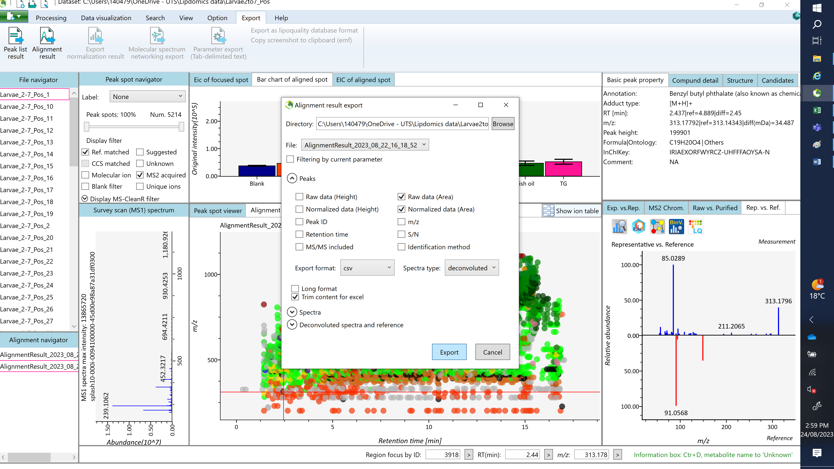

1. It spits out a csv file to open with excel
2. Remove columns F – AE (useless). Last columns are the averages and STdev (but calculate yourself too).
3. Remove all unknowns/suggested as described in column D.
4. Filter by the tag – use only those you ticked.
5. Rename the duplicates you kept (lipid_1, lipid_2…etc)

Output in long format, short format, and file of spectral data for each polarity

Repeat entire process for other ion mode

You can use [www.metaboanalyst.ca](http://www.metaboanalyst.ca) to perform stats.

Will need to do blank corrections and protein normalization